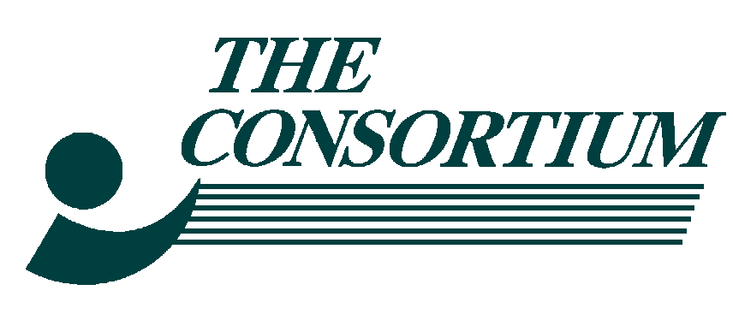 University Center Recovery Center
The Consortium puts RECOVERY First 451 University Ave
Philadelphia, PA 19104
215.596.8000 voice / 215.382.4089 fax

Medication Assisted Treatment Services
Drug and Alcohol Treatment Services

ANNUAL REPORT
2025 – 2026

Financial Statement for Substance Use Recovery Division
FY July 2025 – April 2026

Income: $ 4,585,217
Expenses: $ 4,258,217

MISSION & VISION: The Substance Use Recovery Division’s mission is to assist all who enter to our programs with the necessary tools to help them obtain their recovery and to ensure that they receive all of the behavioral health services needed for substance use disorder and mental health treatment. When we are not able to provide a service, we will connect them to the necessary resources in the community. We strive to always be respectful of an individual’s choice as we inspire those, we serve by giving them hope and resources. We strive to be a model of excellence as we advocate for those we serve. We are committed to develop innovative services based on an ongoing assessment of needs within our immediate and extended geographic community.

ANNUAL OVERVIEW: Activities and Accomplishments: Fiscal Year 25-26 saw treatment challenges defined by an increased use of illicit substances, Fentanyl and Xylazine. Due to increased or continued substance use, several cohorts were assigned to additional group services, individual counseling services, daily on-site medication doses, and repetitive referrals to the Inpatient Level of Care for detox. The inpatient placements stay range from 7 days to two months, depending on the member’s needs and the insurance approvals. For this referral activity a dedicated Clinical Care Manager facilitates all assessments, placements, and follow- up appointments upon the member’s return to the program. The more stable cohorts continue to benefit from take home bottles of medication and psychotherapy services. The program’s collaboration with Spectrum Health services for expanded Integrated Care continues as a strong and collaborative. In addition, The Positive Effect Ministry is on-site one day each week to provide HIV/AIDS Testing and treatment resources.

The dosing population will usually garner the $850 monthly CBH Case Rate Payment for three or more services unless they are referred to a higher level of care. The non-dosing population continues to be the most challenging members to achieve this requirement, as they do not always engage immediately and tend to have sporadic compliance with attendance due to re-engagement with education and employment. To assist these members, we offer evening groups two to four days a week. The program continues to look for different avenues of engagement and have found a modicum of success by including groups facilitated by DBHIDS Core Services Unit to our list of resources. Several cohorts have attended Nutritional Groups, Family Engagement Groups, and the Focus on Fathers resource group which provided the attendees with a certificate of completion and a $200 stipend. Other such resource groups are scheduled and will run in six-to-eight-week intervals. Additionally, the program has contracted with a GED provider. This contractor is currently working with 12 members who are receiving either Adult Education classes to prepare them for the GED classes, or GED classes to prepare for GED testing and certification.

We continue to fully engage with the DBHIDS/ CRAFT community outreach initiative. In addition to sending a small engagement team into the Kensington, West Philadelphia, Southwest Philadelphia, and South Philadelphia communities each week to partner with DBHIDS/CRAFT team. We have seen a positive response to these efforts in the form of new community partnerships with recovery houses and increased admissions. Our program provides resource information, Narcan, Fentanyl Test Strips, and access to assessment appointments for all interested members in the community.

The program is also working closely with our Certified Peer Specialist and attempting to develop a new Community Supports Team, formerly the Consumer Advocacy Group. We have initiated a number of new relationships with community partners to increase our census and expand our cache of supports for participants. During this past year the University City Recovery Center has participated in multiple community resource events.

The program is seeing much stability and success in treatment for the members who take advantage of our Mental Health services which are provided by a psychiatrist. The psychiatrist also provides addictions medical services.

Medication Assisted Treatment: Approved capacity for this activity is 370.
The current census is 132 members.

D&A non-medication Treatment: Approved capacity for this activity is 160. The current census 72.

Challenges with the programs
Agency wide challenges during FY 25-26 contributed to disengagement of some referral sources and members transferring out of the program. The team is making every effort to reengage and increase the census.

Accomplishments
3 Ψεαρ ΧΑΡΦ Αχχρεδιτατιον
Continued partnership with recovery house network
Outstanding results on all city and state audits
Increased Community engagement and outreach efforts

The Consortium Inc. Governing Body (Board of Directors) has authority to approve
the development of performance improvement processes and directs the Substance Use Recovery Division. The Board of Directors includes:
Chair: Ms. Alicia Burbage
Treasurer: Ms. Dawn R. Chism, Esq.
Secretary: Ronda Feimester
Vice-Chair: Ms. Lynesia Liggeons
Member: Ms. Deborah A. Hopkins
Member: Ms. Lynesia Liggeons
Member: Ms. Danyl S. Patterson, ESQUIRE
Member: Ms. Kimberly Gray, LCSW

